Mount Tabor High School: Spring 2021 Hallway Map
ONE WAY TRAFFIC = TWO WAY TRAFFIC =
Stairwells are One Way as Indicated: Up or Down Only

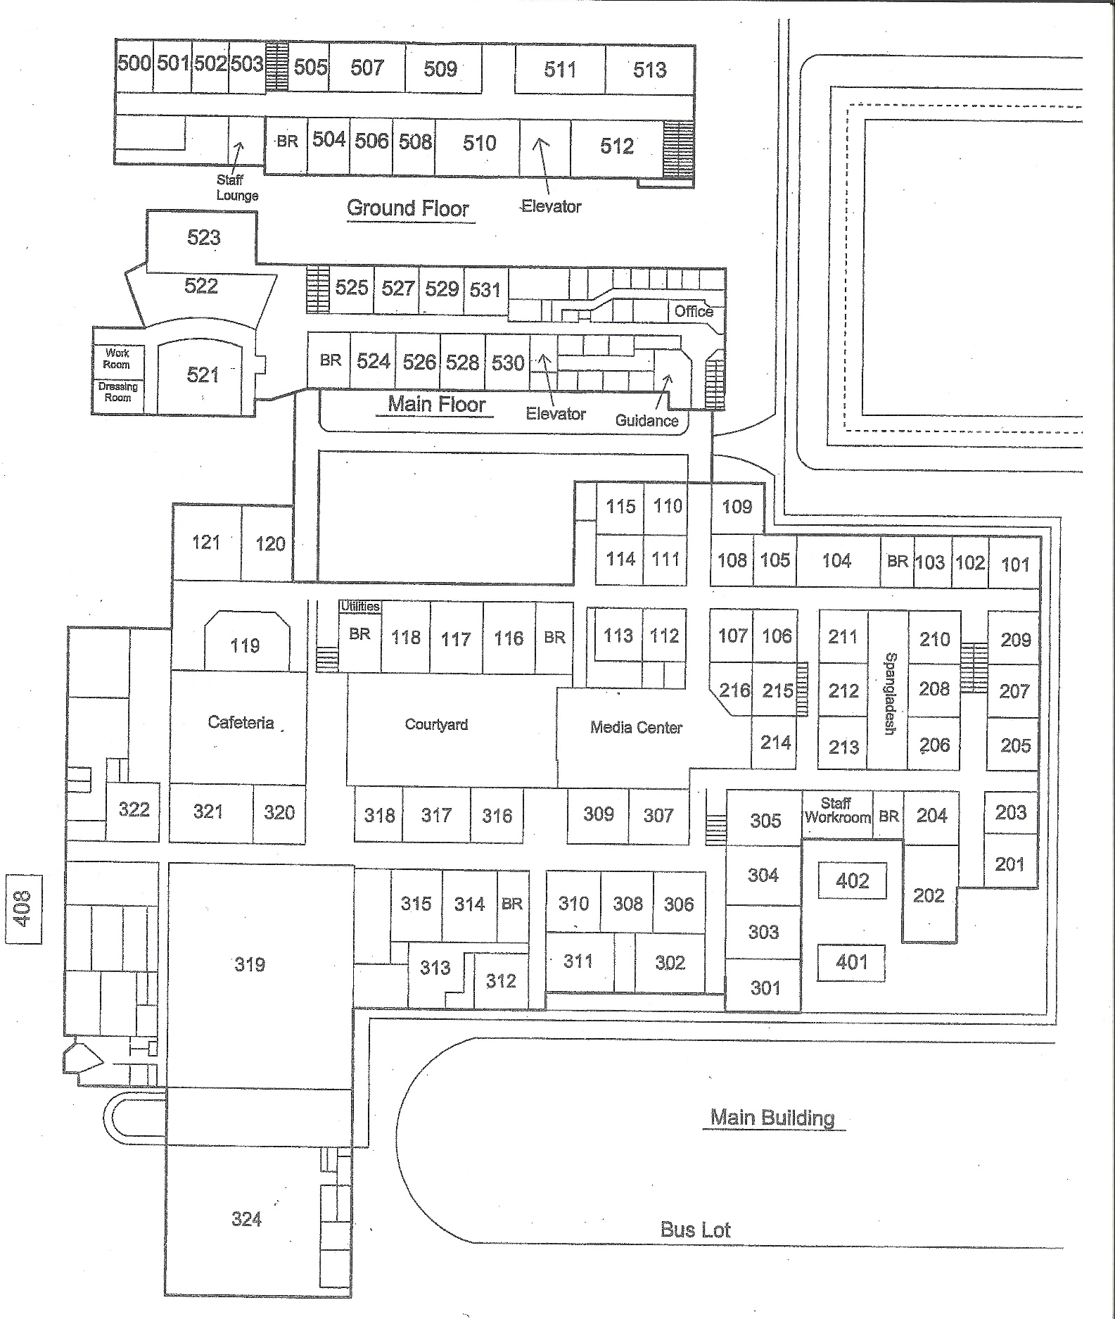
Spartan Way (Outside)
Up Only
Down Only
Down Only
Up Only
Student Parking
Lower 500
Upper 500
Cafeteria
Main
Gym
Aux
Gym
Media
Center
Auditorium
BUS LOT
Main Office
Student Services Office
Student Drop Off/ Pick Up

