- Select the correct graph for each inequality.

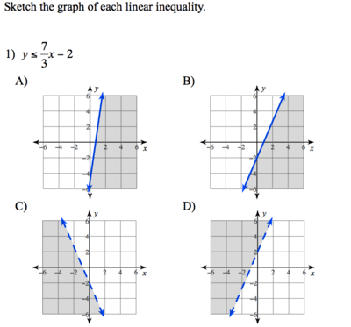
- which equation best represents this graph?

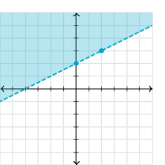

- y < 1/2x + 1
- y < 1/2x + 2
- y >1/2x + 2
- y > 2x

3. Which is true about this graph??

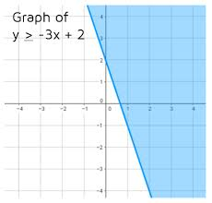
A. it is shaded above and has a dashed line
B. it is shaded below and has a solid line
C. it is shaded above and has a solid line
D. it is shaded below and has a dashed line

- Select the graph for y > -2x – 3

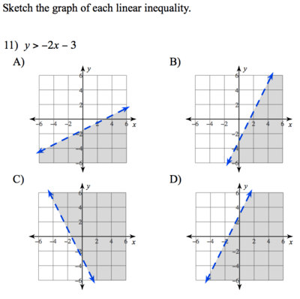

- Select the graph for y ≥ -3.

