1. What is the slope in the equation y=2x + 3?

- 2
- 3
- 5
- Cannot be Determined

2. If m=3 and b=6, what is the correct slope intercept equation?

- y=3-6
- y=3x-6
- y=3x+6
- y=6x+3

3. What is the equation of this line?

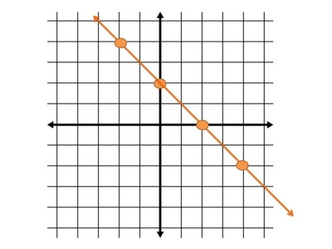
- y = 2x +2
- y = 2x -2
- y = -x + 2
- Cannot be Determined

4. Write the equation of the line.

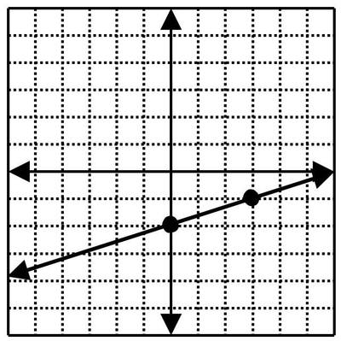
- y = -1/3x - 2
- y = 1/3x - 2
- y = 3x - 2
- y = -3x - 2

5. Write the equation of the line.

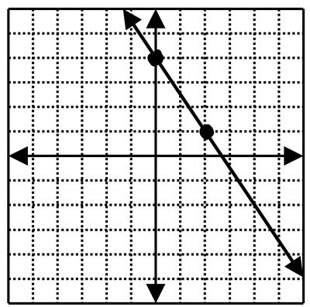
- y = -2/3x + 4
- y = 2/3x + 4
- y = 3/2x + 4
- y = -3/2x + 4

6. What is the y-intercept of the line with the equation
y = −2x + 4

- -2
- 2
- 4
- -4

7. What is the slope of the line with the equation
y = −2/3​x + 4

- -3/2
- 3/2
- 4
- -4

8. Write the equation of the graph in slope-intercept form
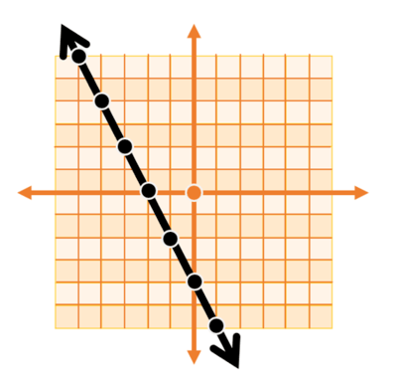
- y= -2x-4
- y= 2x -4
- y= 2/1​x −4
- y= −2/1​ x −4

9. Find the slope

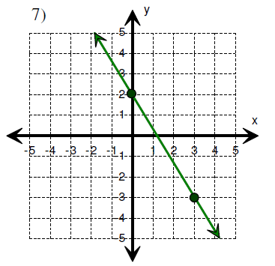
A. -5/3
B. -3/5
C. 5/3
D. 3/5

10. Find the slope:

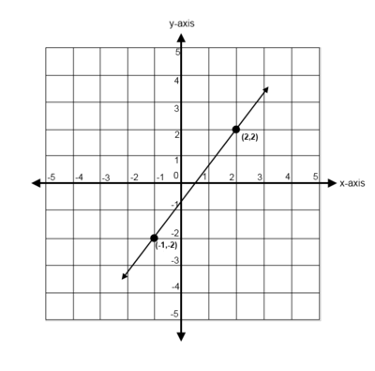
- 3/4
B. 4/3
C. -3/4
D. -4/3

